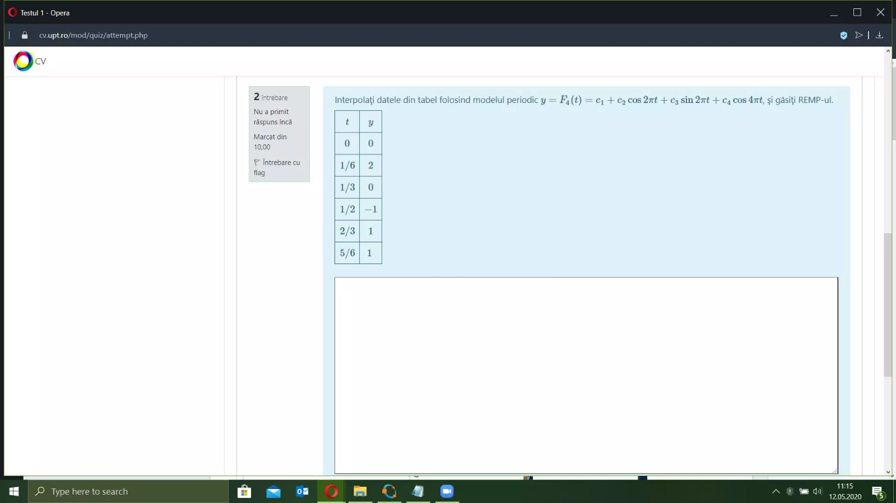

%modelul y = c1 + c2 cos + c3 sin + c4 cos

x0 = [0; 1/6; 1/3; 1/2; 2/3; 5/6];

y0 = [0; 2; 0; -1; 1; 1];

A = [x0.^0 cos(x0.\*2\*pi) sin(x0.\*2\*pi) cos(x0.\*4\*pi)]

%imi rezulta un sistem inconsistend ca sa gasesc c-uri

newA = A'\*A

newB = A'\*y0

c = newA\newB

%calculez valoerile cu modelul

newY = polyval(c, x0);

rest = y0-newY;

norma = norm(rest)

m = length(x0);

REMP = norma/sqrt(m)

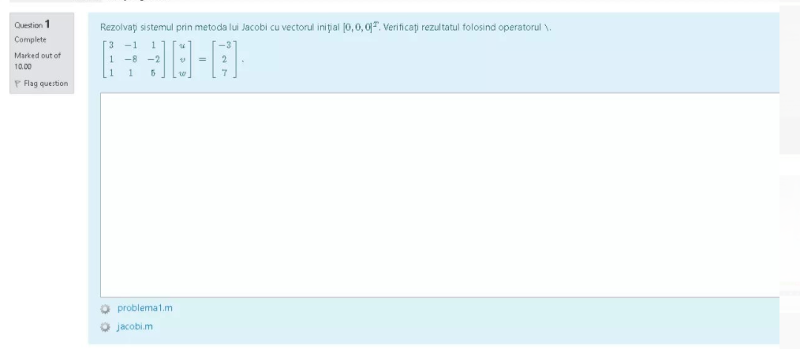

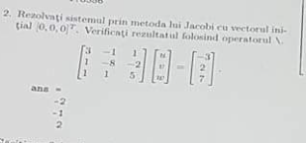

%Metoda lu Jacobi: se da A si vectorul initial

A=[3 -1 1; 1 -8 -2; 1 1 5]

b=[-3; 2; 7]

x=[0;0;0]

D=diag(diag(A))

L=tril(A)-D

U=triu(A)-D

k=20;

for i = 1:k

x=(inv(D)) \* (b-(L+U)\*x);

end

x

%verificare

rezultat=A\b

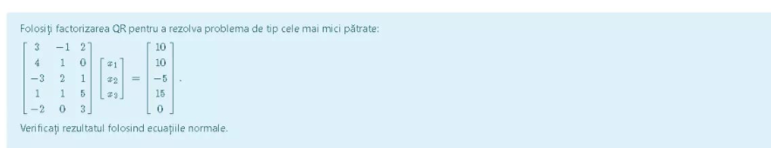

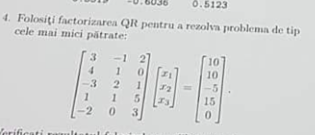

%factorizarea QR si cele mai mici patrate

A=[3 -1 2; 4 1 0; -3 2 1; 1 1 5; -2 0 3]

b=[10; 10; -5; 15; 0]

[Q,R]=qr(A)

%Submatricea n X n superioara a lui R

[m n]=size(A)

R1=R(1:n, 1:n)

d=Q'\*b;

%primele n intrari ale lui d

d1=d(1:n)

%Rezolv ecuatia R1 x = d1

x=R1\d1

%calculez eroarea

bCalc=A\*x;

r=bCalc-b

norma=norm(r)

m=length(r)

REMP=norma/sqrt(m)

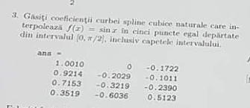

%coeficientii curbei spline

%5 puncte egal departate din 0, pi/2

x=linspace(0, pi/2, 5)

f=@(x)sin(x);

y=f(x)

n=length(x);

A=zeros(n,n);

r=zeros(n,1);

for i=1:n-1

dx(i)=x(i+1)-x(i);

dy(i)=y(i+1)-y(i);

end

for i=2:n-1

A(i, i-1:i+1)=[dx(i-1) 2\*(dx(i-1)+dx(i)) dx(i)];

r(i)=3\*(dy(i)/dx(i) - dy(i-1)/dx(i-1));

end

A(1,1)=1;

A(n,n)=1;

coeff=zeros(n,3);

coeff(:,2)=A\r;

for i=1:n-1

coeff(i,3)=(coeff(i+1,2)-coeff(i,2))/(3\*dx(i));

coeff(i,1)=dy(i)/dx(i)-dx(i)\*(2\*coeff(i,2)+coeff(i+1, 2))/3;

end

coeff=coeff(1:n-1, 1:3)

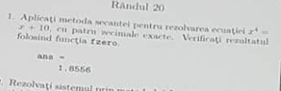

%function xc=secant(f, x0, x1, k)

%x0, x1, valori initiale, k - nr de pasi

x0=0;

x1=2;

k=5;

f=@(x)(x^4 - x - 10)

for i=1:k

x2=x1-(f(x1)\*(x1-x0))/(f(x1)-f(x0))

if(f(x2)==0)

break;

end

aux=x1;

x1=x2;

x0=aux;

end

%verificare

radacina=fzero(f, 2)



%metoda bisectie cu 4 zecimale exacte

f=@(x) (cos(x)^2-x-6)

fsolve(f, 0)

a=-6;

b=-5;

fa=f(a);

fb=f(b);

if sign(fa)\*sign(fb) >= 0

error('f(a)f(b)<0 not satisfied!')

end

tol = 0.00001

while (b-a)/2>tol

c=(a+b)/2;

fc=f(c);

if fc == 0

break;

end

if sign(fc)\*sign(fa)<0

b=c;

fb=fc;

else

a=c;

fa=fc;

end

end

xc=(a+b)/2